**Advanced Java:**

**Pre-requisites:**

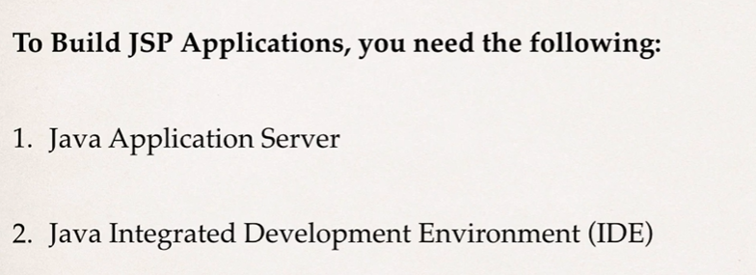

**Tomcat installation:**



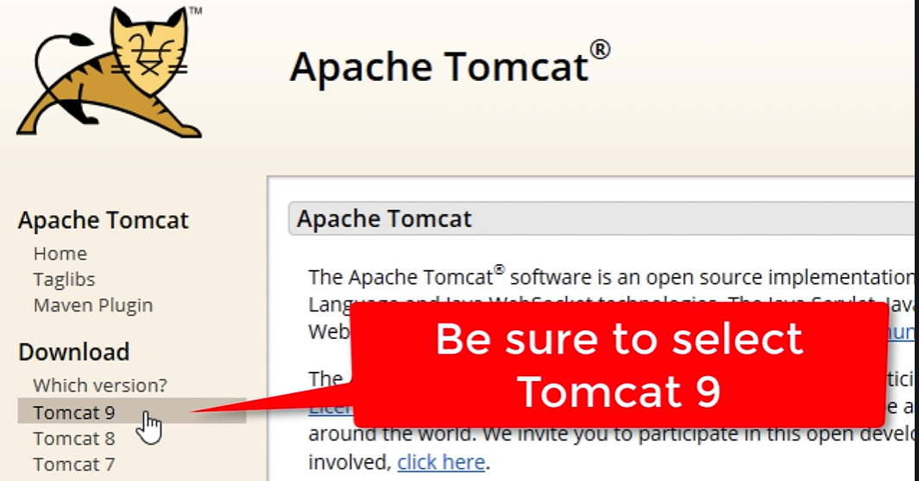

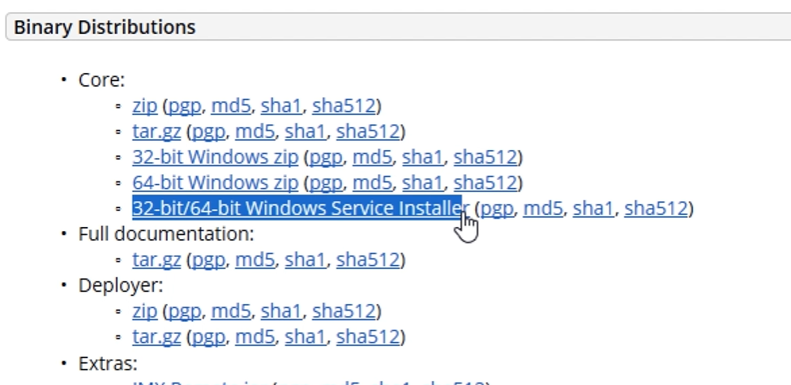

**Download 🡪 go to download location and double click on the file.**

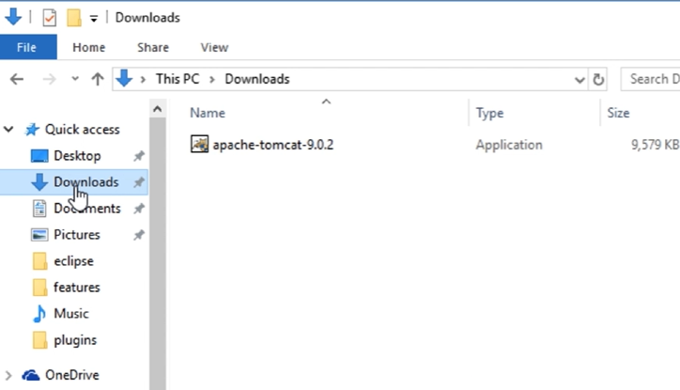

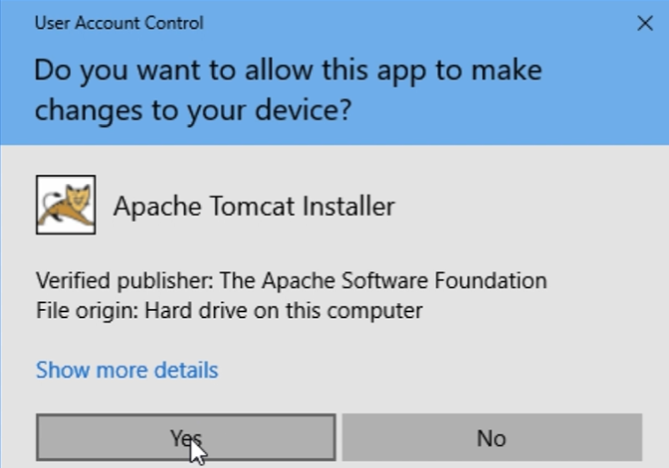

**Yes 🡪 Next 🡪 Agree 🡪 select Full**

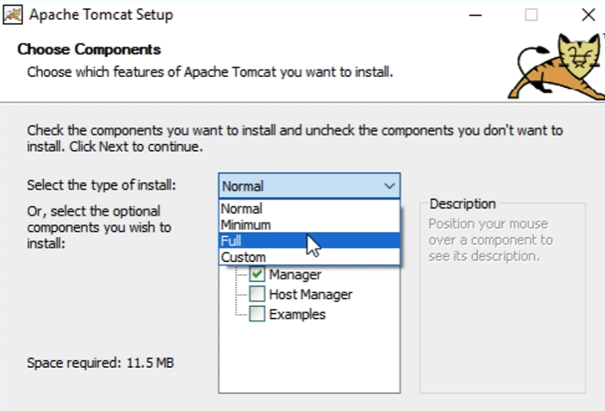

**Make sure all check boxes are ticked.**

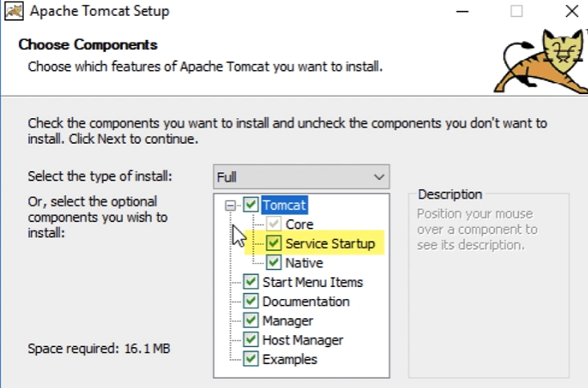

**Click Next and enter PORT details if missing and give username/passwork: admin/admin 🡪 Next**

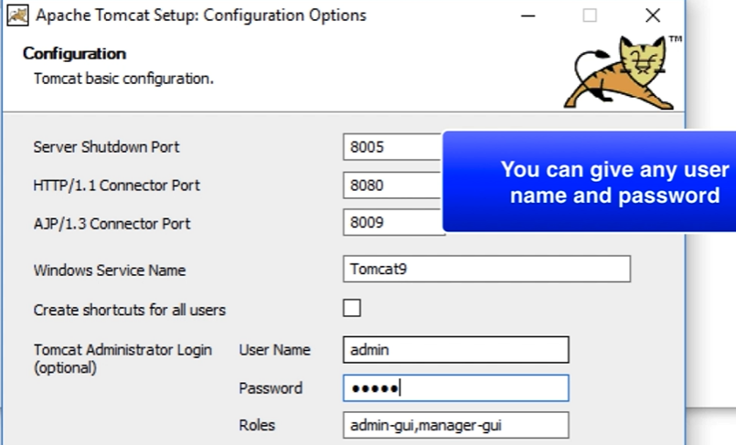

**Default Java location is selected 🡪 select java path which you are using for the project.**

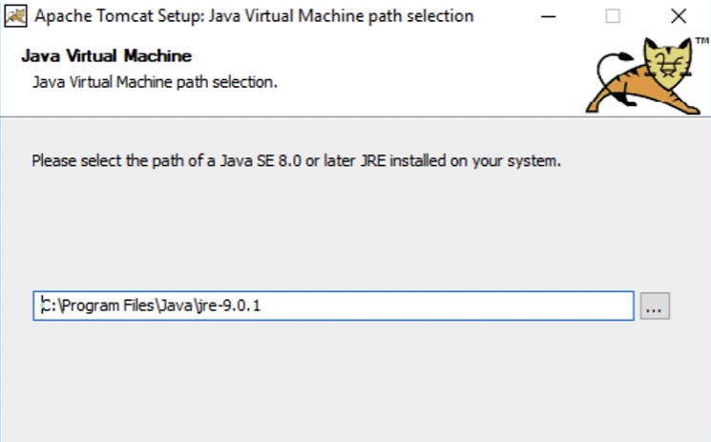

**Click Next 🡪 Next 🡪 Finish**

**Verify the installation -> open browser 🡪 Enter URL 🡪 Click ENTER**

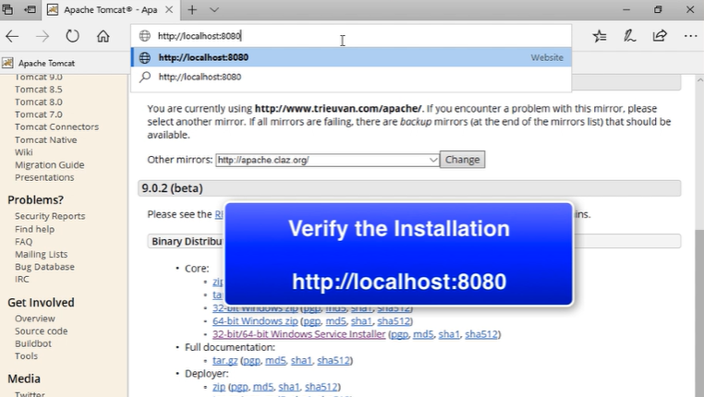

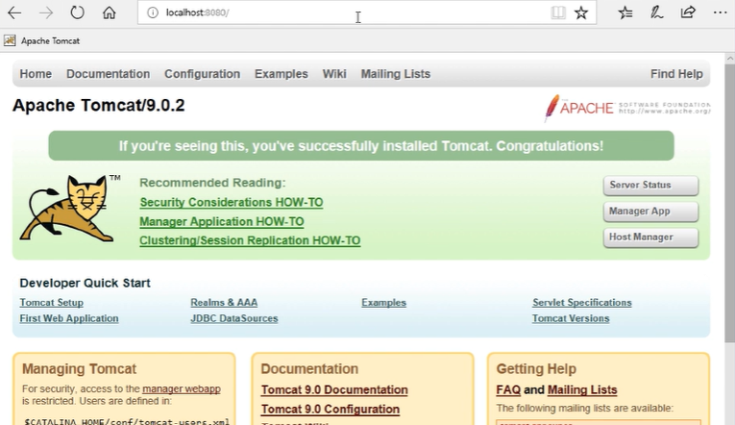

**To Configure:**

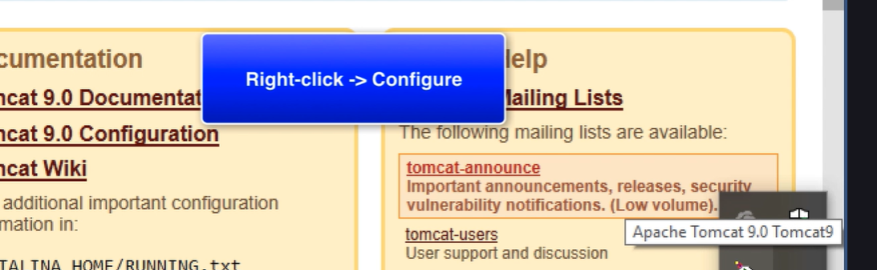

**Check Services:**

**Open Control Panel 🡪 Enter Services.**

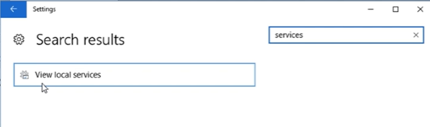

**Start/Stop/Restart the apache server**

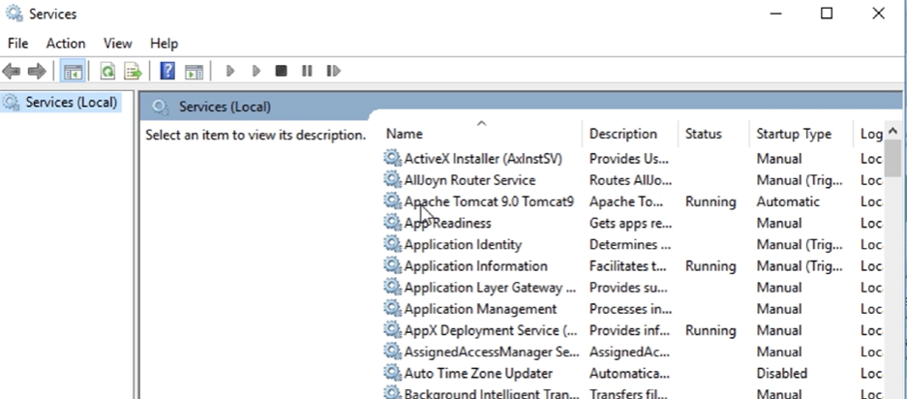

**For now, right click and select Stop 🡪 Stop the service.**

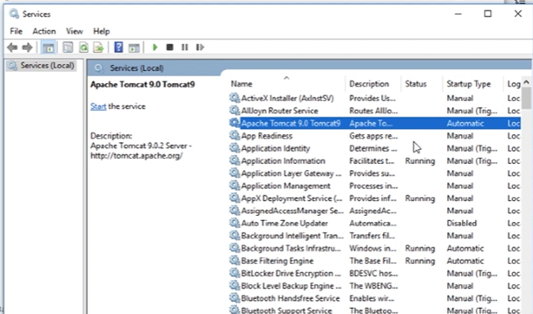

**Eclipse:**

**Make sure Eclipse IDE is 🡪 Java developers and Web Developers.**

**Connecting Eclipse to Tomcat:**

**Open Eclipse 🡪 Select Existing Workspace 🡪 Go to Servers Tab**

**Note:**

**If Server tab is not displaying, Go to Windows menu 🡪 Show View 🡪 Server**

**Step1:**

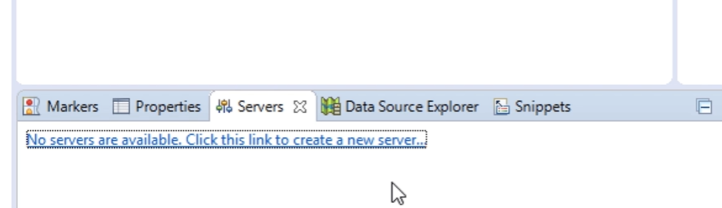

**Step2:**

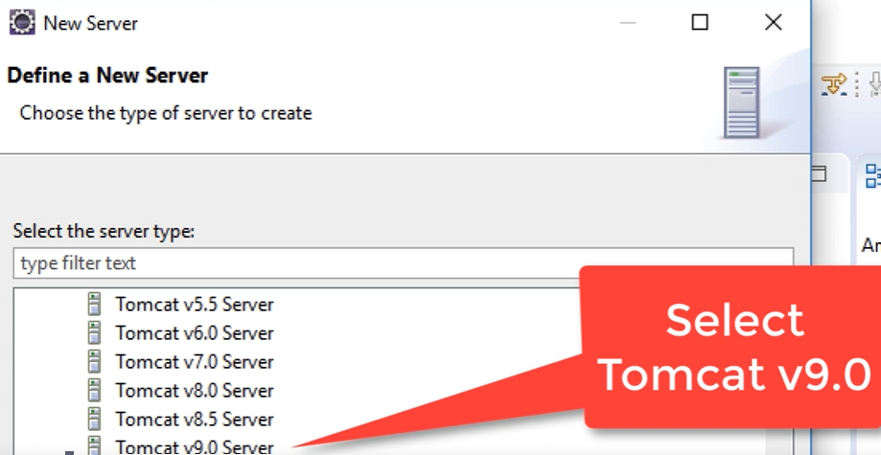

**Step3:**

**Browse and Select Tomcat installation directory**

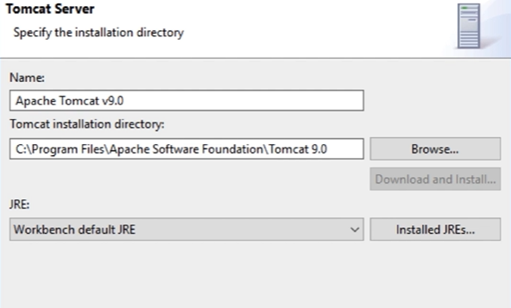

**Step4:**

**Click Next 🡪 Next 🡪 Finish**

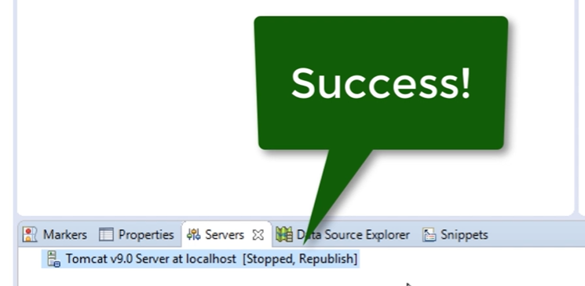

**What is JSP and Servlets:**

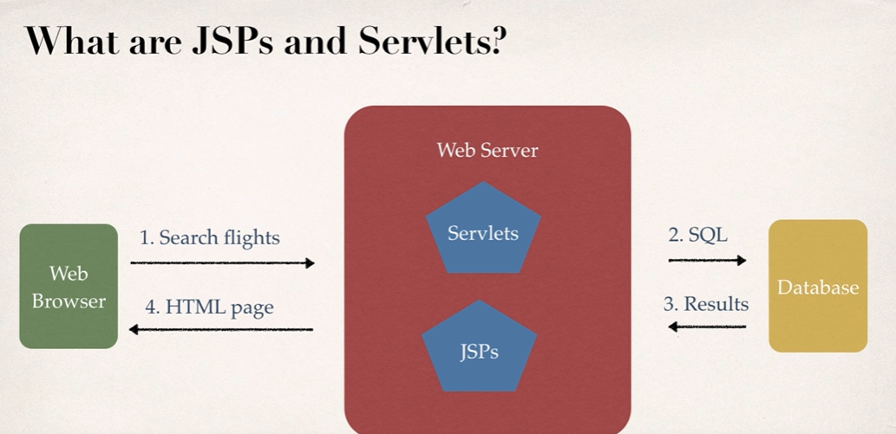

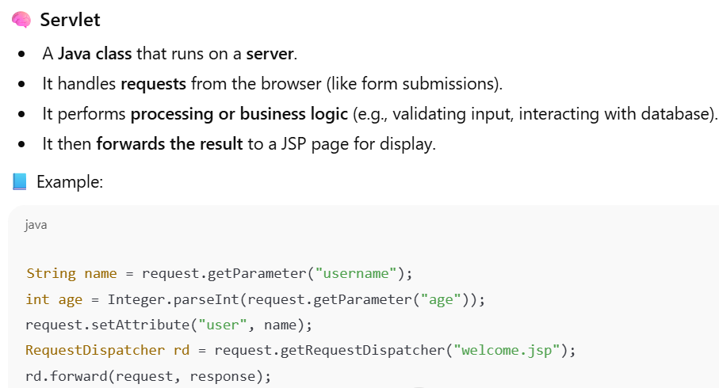

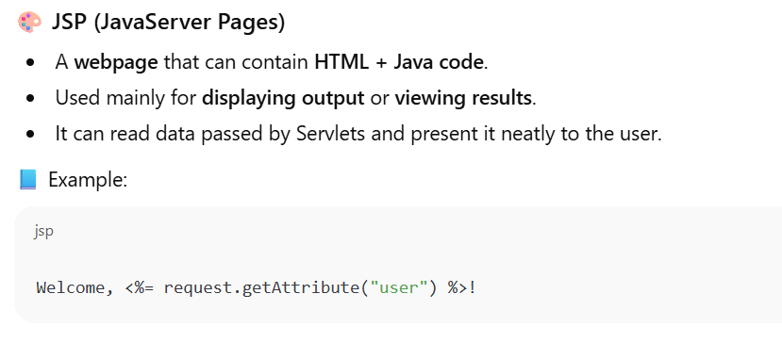

**Diagram:**

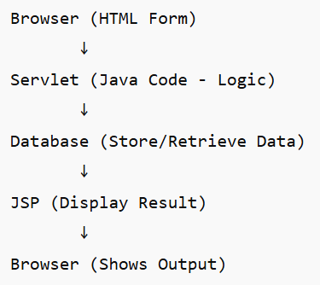

**Flow**:

1. **Browser (Client)**  
   → Sends a request (e.g., submitting an HTML form or clicking a link).  
   Example:

<form action="LoginServlet" method="post">

Username: <input name="user">

Password: <input name="pass">

<input type="submit">

</form>

1. **Servlet (Controller)**  
   → Receives the request using HttpServletRequest.  
   → Processes the logic (validation, DB query, etc.).  
   → Optionally connects to the **Database** via JDBC.  
   → Stores the results (like success message or data).  
   → Forwards the request to a **JSP** for display.
2. **Database (Model)**  
   → Stores or retrieves the required data.  
   Example: SELECT * FROM users WHERE username=?
3. **JSP (View)**  
   → Receives processed data from Servlet.  
   → Displays the response (HTML + dynamic content).  
   Example: “Welcome, Suresh!”
4. **Browser (Client)**  
   → Finally receives the **HTML response** and displays it to the user.

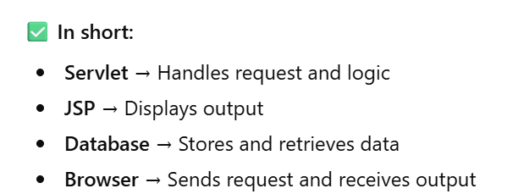

**Eclipse IDE:**

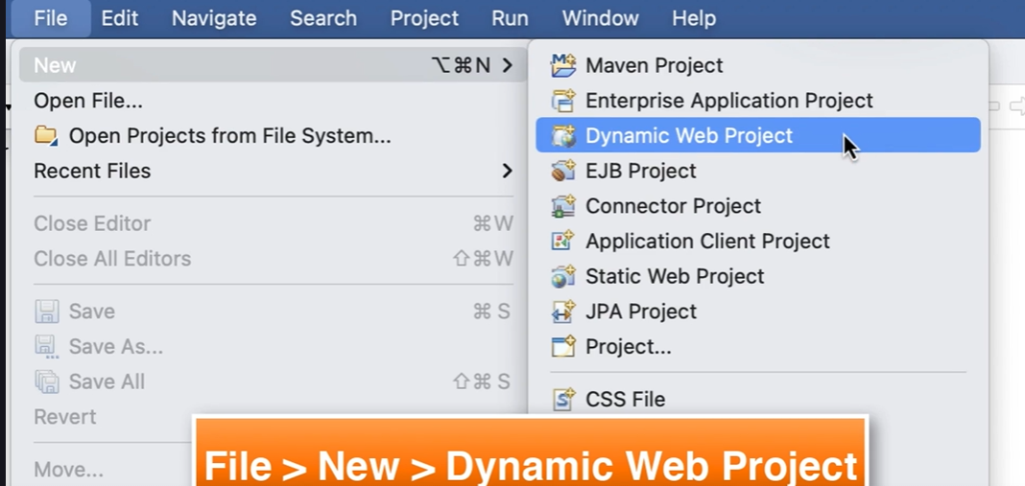

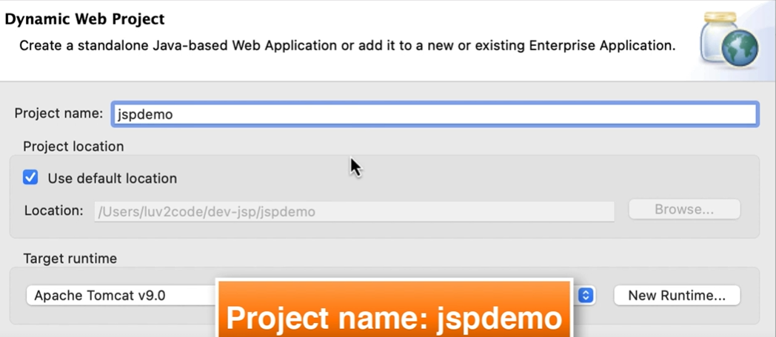

**Select Project Location 🡪 Click on Next**

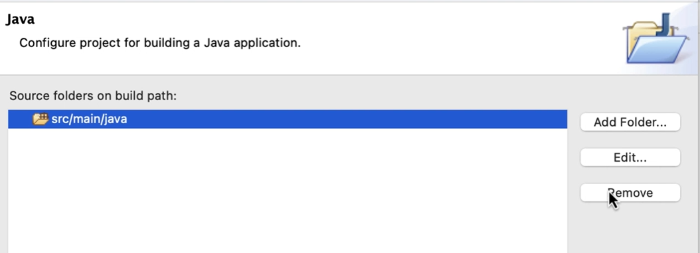

**Remove and add,**

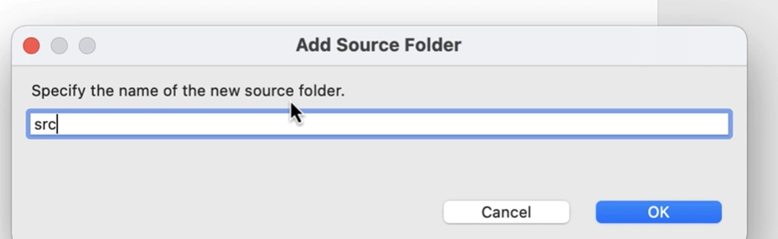

**Click Next and change Content Directory name. select Checkbox for web.xml**

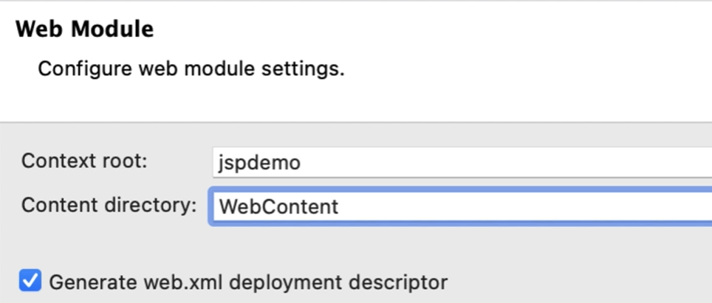

**Click on Finish**

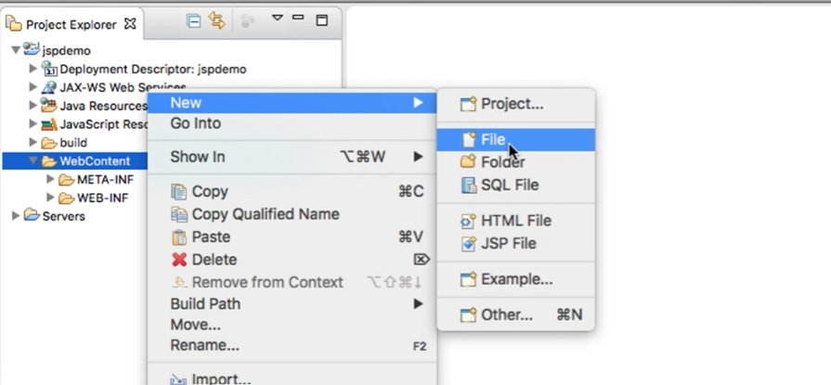

**JSP Hello World**

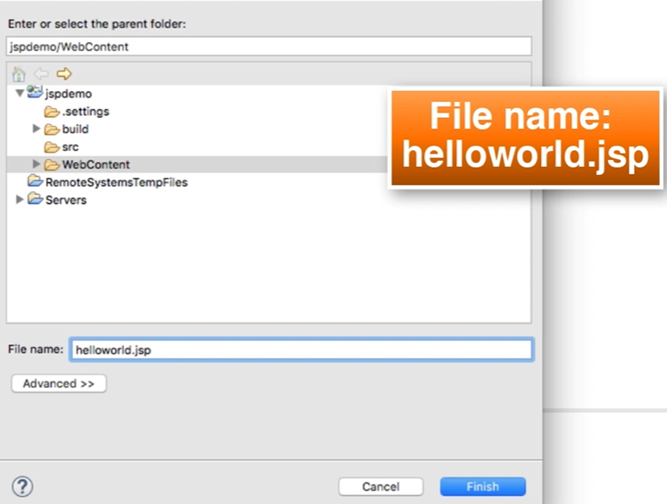

**Click on Finish.**

**Enter the program and click on save:**



**<html>**

**<body>**

**<h3>Hello World of Java!</h3>**

**The time on the server is <%= new java.util.Date() %>**

**</body>**

**</html>**

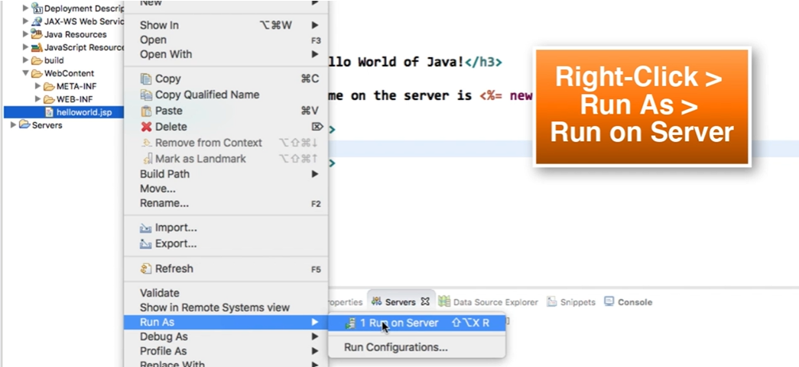

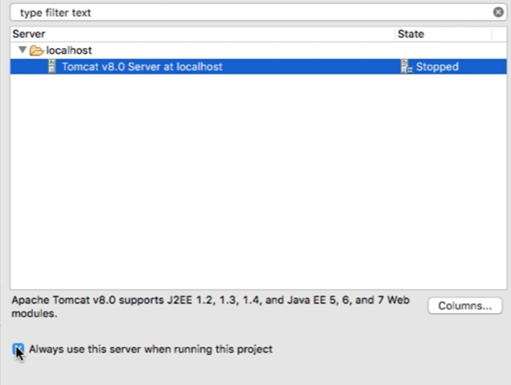

**Click on Finish**

**Note: Change server port and connector port if not working.**

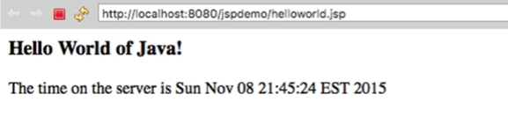

**Copy and Past the URl in any browser.**

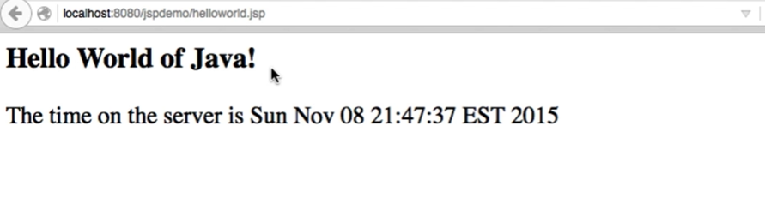

**Now, right + click and do view pagesource 🡪 which takes to the .jsp page**

**JSP Scripting Elements:**

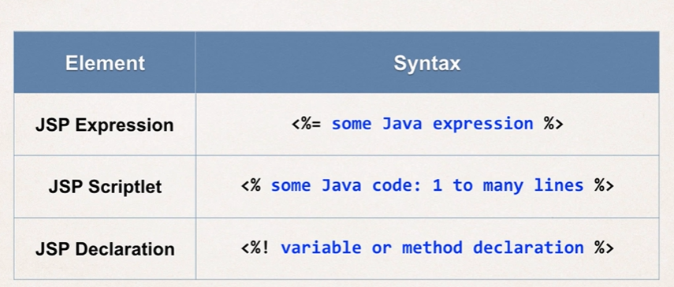

**JSP Expression:**



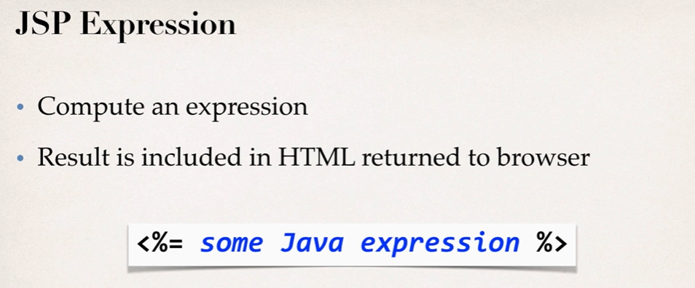

**Example1:**

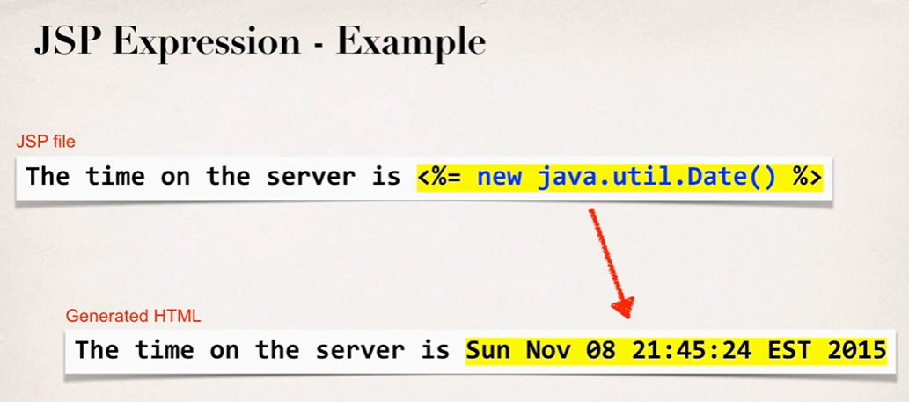

**Example2:**

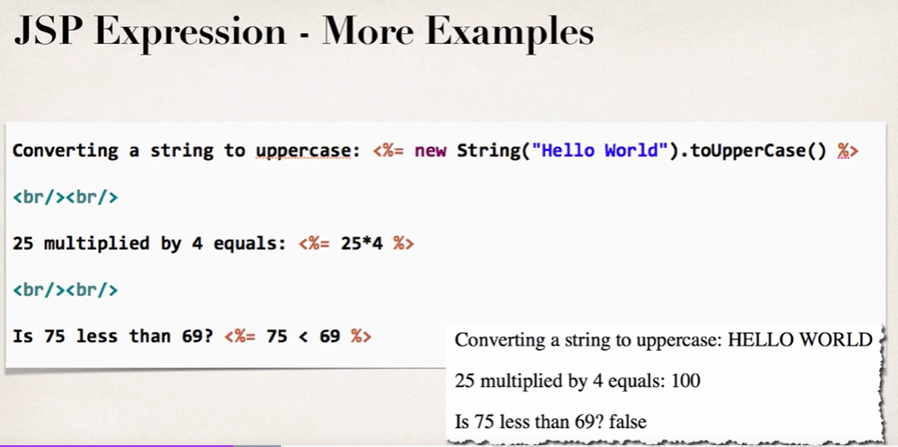

**JSP Scriplet:**



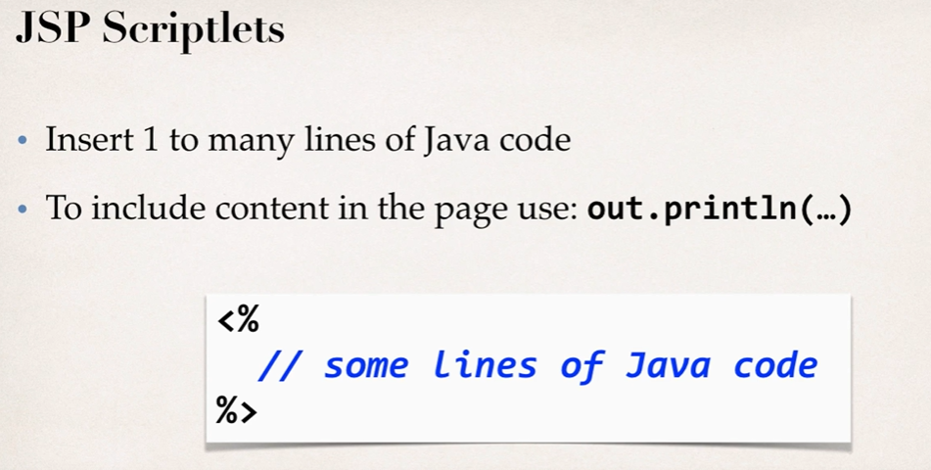

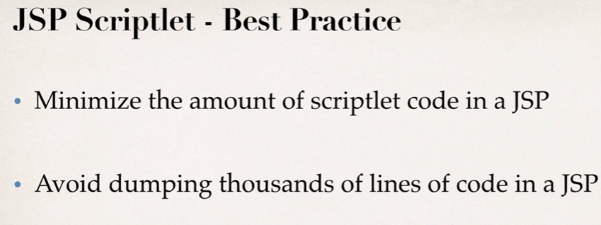

**JSP Declarations:**



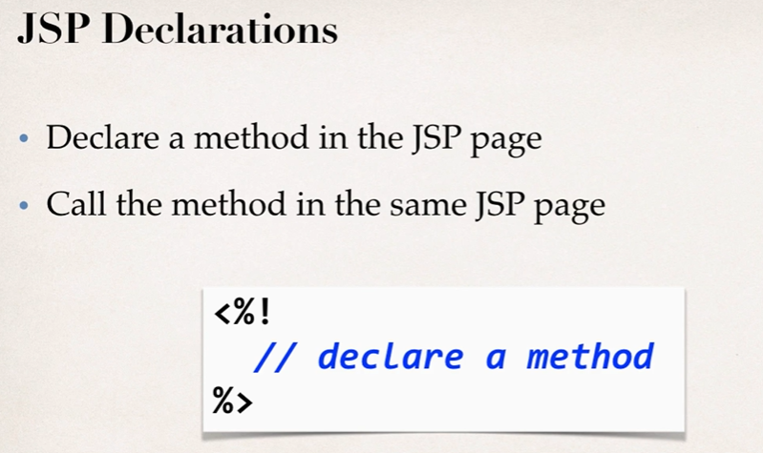

**Calling a Java Class from JSP**

1. Create a Java class
2. Call a java class from JSP.

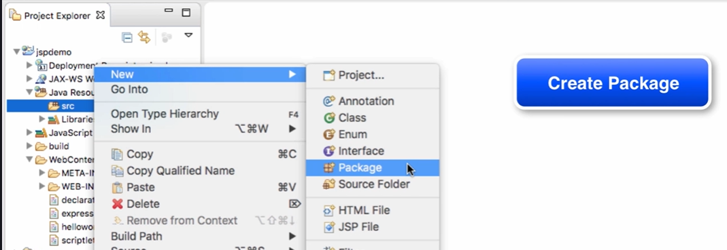

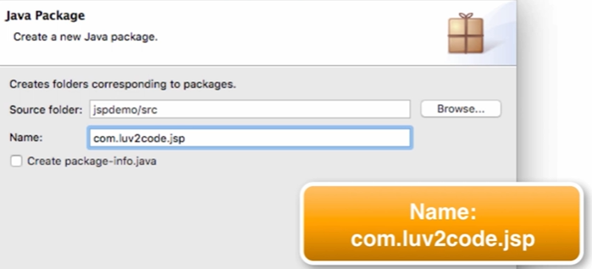

Click on Finish

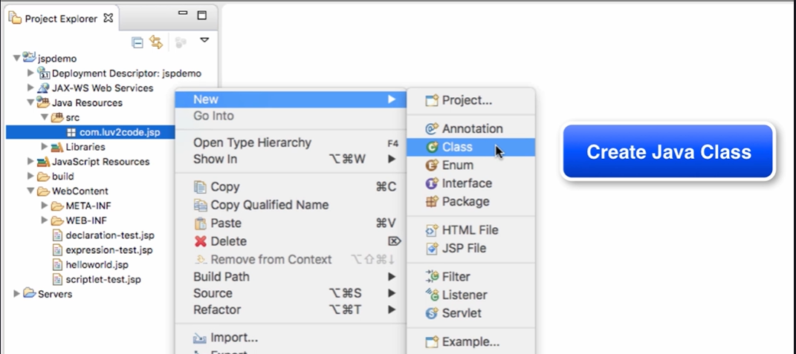

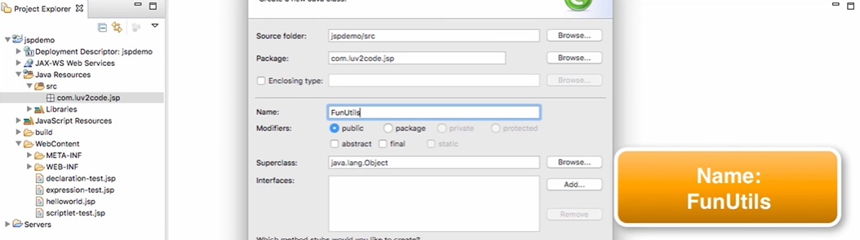

Click on Finish

**Enter the Java Code:**



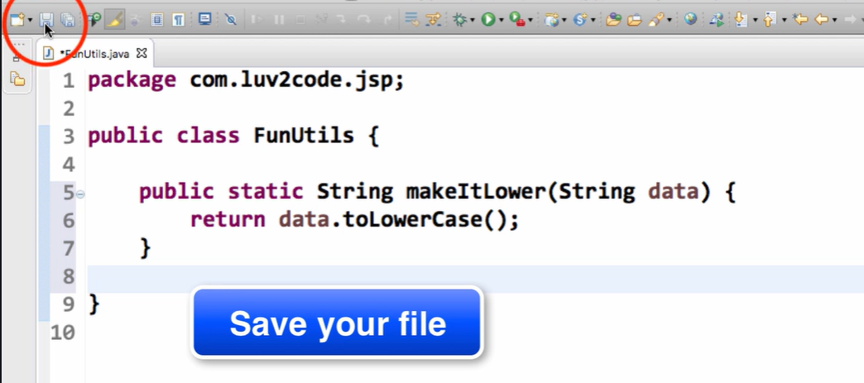

**Now, Create JSP file.**

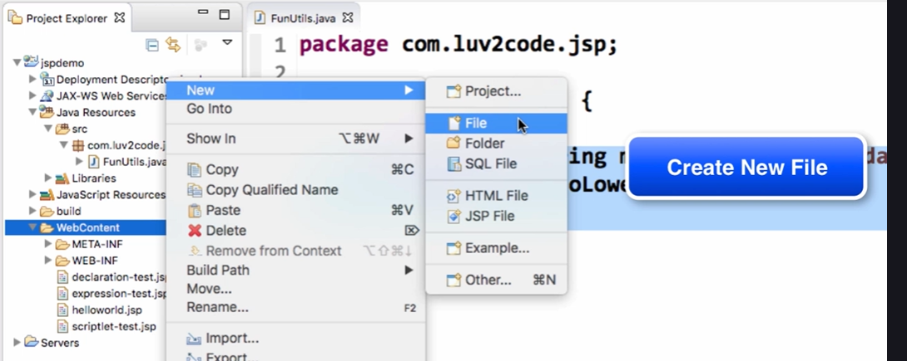

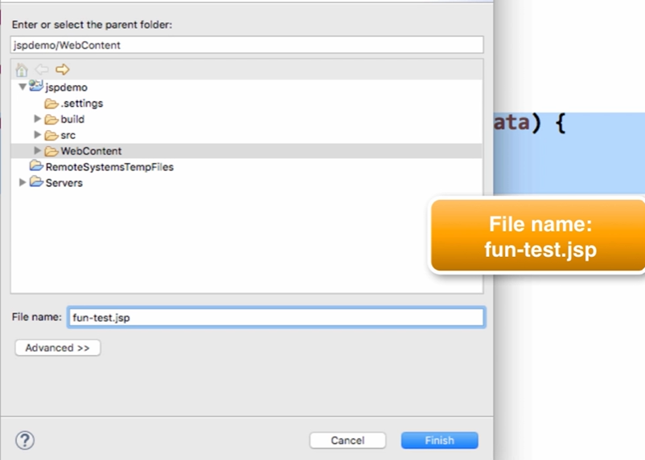

**Click Finish and enter the attached code below in JSP file.**



**Run as 🡪 Run on server**

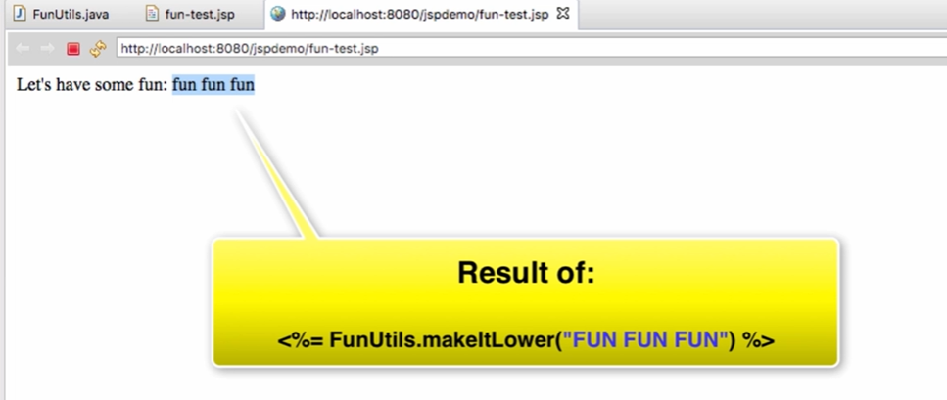

**JSP Built-in Objects:**

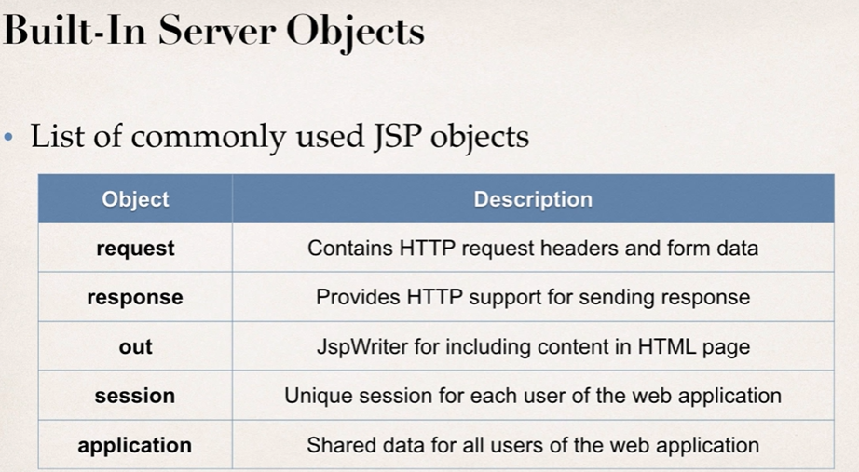

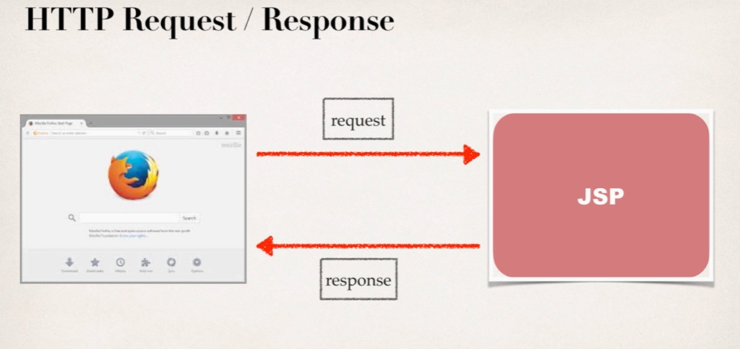

Create JSP file -> Run as 🡪 Run on server



**Output:**

Browser version etc.. with language used.

**Including Files in JSP**



Also Create, my-header.html

<h1 align=”center”>Java Class</h1>

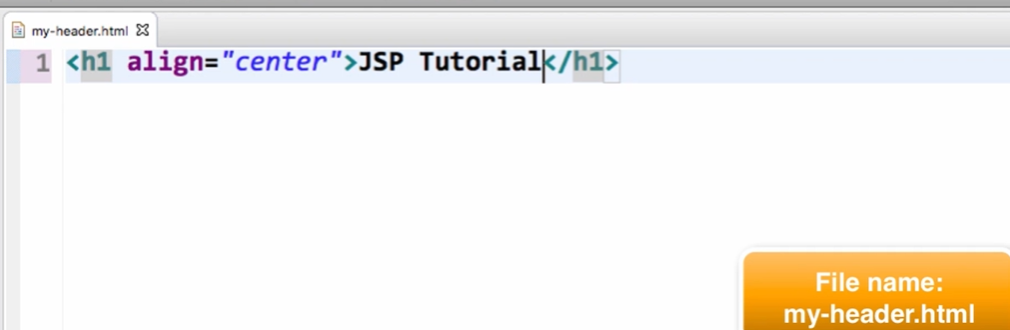

Homepage.jsp 🡪 Run as 🡪 Run on Server

**Reading HTML Form Data with JSP:**

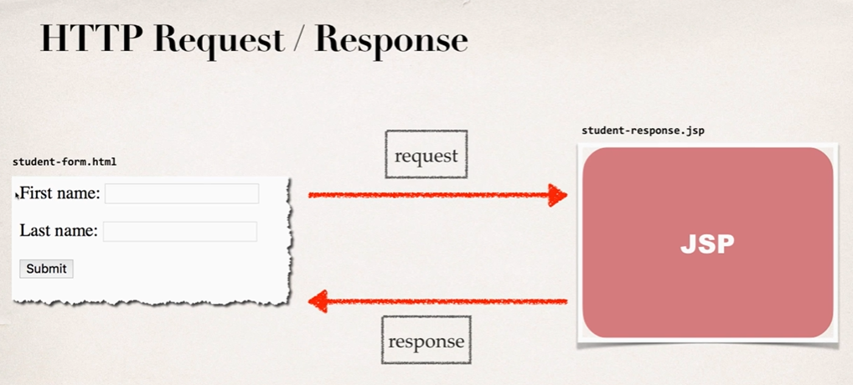

**HTML Form:**

1. Create new file “**student-form.html**”

<html>

<head><title>Student Registration Form</title></head>

<body>

<form action="student-response.jsp">

First name: <input type="text" name="firstName" />

<br/><br/>

Last name: <input type="text" name="lastName" />

<br/><br/>

<input type="submit" value="Submit" />

</form>

</body>

</html>

1. Create new file “**student-form.jsp**”

<html>

<head><title>Student Confirmation Title</title></head>

<body>

The student is confirmed: ${param.firstName} ${param.lastName}

</body>

</html>

1. Execute “**student-form.html**” 🡪 Run as 🡪 Run on server
2. Output: The student is confirmed:<firstname><lastname>

**Drop Down Lists:**

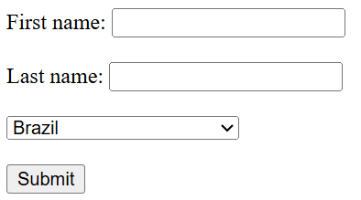

1. Step1: Create new file “**student-dropdown-form.html**”

<html>

<head><title>Student Registration Form</title></head>

<body>

<form action="student-dropdown-response.jsp">

First name: <input type="text" name="firstName" />

<br/><br/>

Last name: <input type="text" name="lastName" />

<br/><br/>

<select name="country">

<option>Brazil</option>

<option>France</option>

<option>Germany</option>

<option>India</option>

<option>Turkey</option>

<option>United Kingdom</option>

<option>United States of America</option>

</select>

<br/><br/>

<input type="submit" value="Submit" />

</form>

</body>

</html>

1. Step2: Create new file “**student-dropdown-response.jsp**”



1. Execute “**student-dropdown-form.html**” 🡪 Run as 🡪 Run on server
2. Output:

**Radiobutton:**

1. Step1: Create new file “**student-radio-form.html**”

<html>

<head><title>Student Registration Form</title></head>

<body>

<form action="student-radio-response.jsp">

First name: <input type="text" name="firstName" />

<br/><br/>

Last name: <input type="text" name="lastName" />

<br/><br/>

<input type=" radio" name="favoriteLanguage" value="Java"> Java

<input type=" radio" name="favoriteLanguage" value="C#"> C#

<input type=" radio" name="favoriteLanguage" value="PHP"> PHP

<input type=" radio" name="favoriteLanguage" value="Ruby"> Ruby

<br/><br/>

<input type="submit" value="Submit" />

</form>

</body>

</html>

1. Step2: Create new file “**student-radio-response.jsp**”



1. Execute “**student-radio.html**” 🡪 Run as 🡪 Run on server
2. Output:

**Checkbox:**

1. Step1: Create new file “**student-checkbox-form.html**”

<html>

<head><title>Student Registration Form</title></head>

<body>

<form action="student-checkbox-response.jsp">

First name: <input type="text" name="firstName" />

<br/><br/>

Last name: <input type="text" name="lastName" />

<br/><br/>

<input type="checkbox" name="favoriteLanguage" value="Java"> Java

<input type="checkbox" name="favoriteLanguage" value="C#"> C#

<input type="checkbox" name="favoriteLanguage" value="PHP"> PHP

<input type="checkbox" name="favoriteLanguage" value="Ruby"> Ruby

<br/><br/>

<input type="submit" value="Submit" />

</form>

</body>

</html>

1. Step2: Create new file “**student-checkbox-response.jsp**”



1. Execute “**student-checkbox-form.html**” 🡪 Run as 🡪 Run on server
2. Output:

**JSP Standard Tag Library(JSTL):**

It’s a collection of **ready-made tags** (like <c:forEach>, <c:if>, etc.) that make it easier to write JSP pages **without using Java code (scriptlets)** inside HTML.

**Why JSTL is Used**

* To **avoid Java code inside JSP** (cleaner pages)
* To **simplify common tasks** like:
  + looping
  + conditional checks
  + formatting

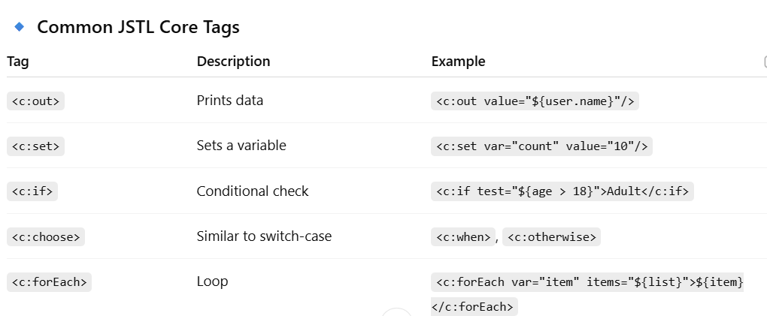

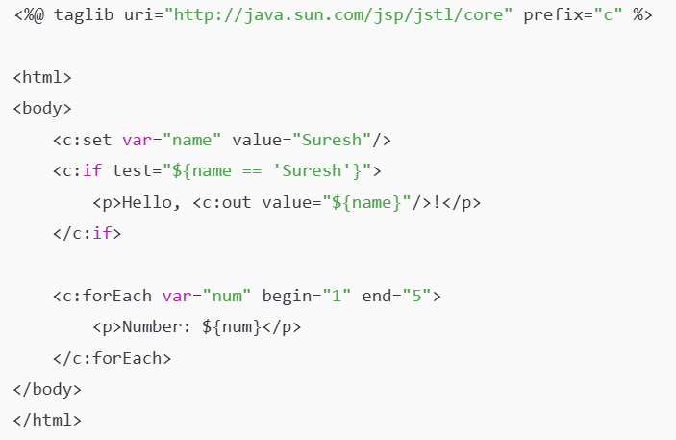

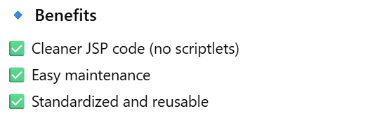

**Install JSTL Jars:**

Create new dynamic project

Project Name: tagdemo

Source folder “src”(remove 🡪 src/java/main)

Content Directory: WebContent

Click Finish

**How to add jars?**

Go to WenContent Folder 🡪 WED-INF (Copy the below jars and paste it)



Create new file in WebContent 🡪 “test.jsp”

<%@ taglib uri="http://java.sun.com/jsp/jstl/core" prefix="c" %>

<html>

<body>

<c:set var="stuff" value="<%= new java.util.Date() %>" />

Time on the server is ${stuff}

</body>

</html>

**Core Tags:**

Core tags handle **basic flow control, variable management, and iteration** — things similar to what you do with Java logic.

**Common Tasks:**

* Setting or getting variables
* Conditional checks
* Loops
* URL and parameter handling

**Programs**

**Looping with forEach:**

Create new file in Webcontent : “**foreach-simple-test.jsp**”

<%@ taglib uri="http://java.sun.com/jsp/jstl/core" prefix="c" %>

<%

String[] cities = {"Mumbai", "Singapore", "Philadelphia"};

pageContext.setAttribute("myCities", cities);

%>

<html>

<body>

<c:forEach var="tempCity" items="${myCities}">

${tempCity} <br/>

</c:forEach>

</body>

</html>

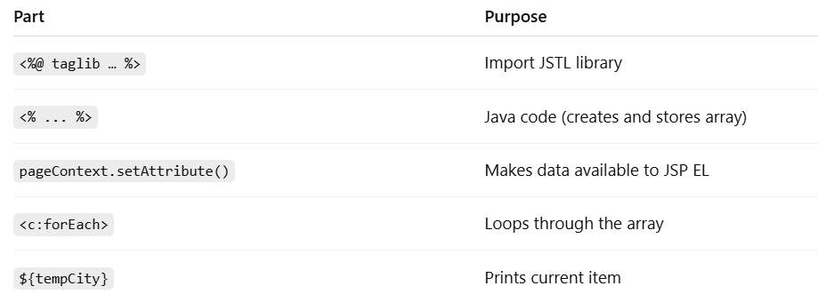

**Looping with HTML Table:**

1. Step1: Create new package in src(or use existing) new file “**student.java**”

package com.demo.jsp.tagdemo;

public class Student {

private String firstName;

private String lastName;

private boolean goldCustomer;

public Student(String firstName, String lastName, boolean goldCustomer) {

super();

this.firstName = firstName;

this.lastName = lastName;

this.goldCustomer = goldCustomer;

}

public String getFirstName() {

return firstName;

}

public void setFirstName(String firstName) {

this.firstName = firstName;

}

public String getLastName() {

return lastName;

}

public void setLastName(String lastName) {

this.lastName = lastName;

}

public boolean isGoldCustomer() {

return goldCustomer;

}

public void setGoldCustomer(boolean goldCustomer) {

this.goldCustomer = goldCustomer;

}

}

1. Step2: Create new file “**foreach-student-test.jsp**”

<%@ taglib uri="http://java.sun.com/jsp/jstl/core" prefix="c" %>

<%@ page import="java.util.*,com.demo.jsp.tagdemo.Student" %>

<%

List<Student> data = new ArrayList<>();

data.add(new Student("John", "Doe", false));

data.add(new Student("Maxwell", "Johnson", false));

data.add(new Student("Mary", "Public", true));

pageContext.setAttribute("myStudents", data);

%>

<html>

<body>

<table border="1">

<tr>

<th>First Name</th>

<th>Last Name</th>

<th>Gold Customer</th>

</tr>

<c:forEach var="tempStudent" items="${myStudents}">

<tr>

<td>${tempStudent.firstName}</td>

<td>${tempStudent.lastName}</td>

<td>${tempStudent.goldCustomer}</td>

</tr>

</c:forEach>

</table>

</body>

</html>

1. Execute “**foreach-student-test.jsp**” 🡪 Run as 🡪 Run on server
2. Output:

**IF tag:**

Used for **simple, single-condition checks** (like a basic if statement in Java).

Create new file “**if-student-test.jsp**”

<%@ taglib uri="http://java.sun.com/jsp/jstl/core" prefix="c" %>

<%@ page import="java.util.*,com.demo.jsp.tagdemo.Student" %>

<%

List<Student> data = new ArrayList<>();

data.add(new Student("John", "Doe", false));

data.add(new Student("Maxwell", "Johnson", false));

data.add(new Student("Mary", "Public", true));

pageContext.setAttribute("myStudents", data);

%>

<html>

<body>

<table border="1">

<tr>

<th>First Name</th>

<th>Last Name</th>

<th>Gold Customer</th>

</tr>

<c:forEach var="tempStudent" items="${myStudents}">

<tr>

<td>${tempStudent.firstName}</td>

<td>${tempStudent.lastName}</td>

<td>

//Display Special Discount is student is Gold Customer

<c:if test="${tempStudent.goldCustomer}">

Special Discount

</c:if>

<c:if test="${not tempStudent.goldCustomer}">

No Special Dicount

</c:if>

</td>

</tr>

</c:forEach>

</table>

</body>

</html>

**Choose**

like a Java if–else if–else chain or a switch statement.

Create new file “**choose-student-test.jsp**”

<%@ taglib uri="http://java.sun.com/jsp/jstl/core" prefix="c" %>

<%@ page import="java.util.*,com.demo.jsp.tagdemo.Student" %>

<%

List<Student> data = new ArrayList<>();

data.add(new Student("John", "Doe", false));

data.add(new Student("Maxwell", "Johnson", false));

data.add(new Student("Mary", "Public", true));

pageContext.setAttribute("myStudents", data);

%>

<html>

<body>

<table border="1">

<tr>

<th>First Name</th>

<th>Last Name</th>

<th>Gold Customer</th>

</tr>

<c:forEach var="tempStudent" items="${myStudents}">

<tr>

<td>${tempStudent.firstName}</td>

<td>${tempStudent.lastName}</td>

<td>

<c:choose>

<c:when test="${tempStudent.goldCustomer}">

Special Discount

</c:when>

<c:otherwise>

no soup for you!

</c:otherwise>

</c:choose>

</td>

</tr>

</c:forEach>

</table>

</body>

</html>

**Function Tags**

Function tags provide **helper functions for working with strings and collections**, similar to built-in Java methods like String.contains() or String.length().

**JSTL Function Tags - length, toUpperCase and startsWith:**

Create new file “**function-test.jsp**”

<%@ taglib uri="http://java.sun.com/jsp/jstl/core" prefix="c" %>

<%@ taglib uri="http://java.sun.com/jsp/jstl/functions" prefix="fn" %>

<html>

<body>

<c:set var="data" value="democode" />

Length of the string <b>${data}</b>: ${fn:length(data)}

<br/><br/>

Uppercase version of the string <b>${data}</b>: ${fn:toUpperCase(data)}

<br/><br/>

Does the string <b>${data}</b> start with <b>demo</b>?: ${fn:startsWith(data, "dem")}

</body>

</html>

**Output:**

Length of the string democode: 8

Uppercase version of the string democode: DEMOCODE

Does the string democode start with demo?: true

**JSTL Function Tags - split and join:**

Create new file “**split-join-test.jsp**”

<%@ taglib uri="http://java.sun.com/jsp/jstl/core" prefix="c" %>

<%@ taglib uri="http://java.sun.com/jsp/jstl/functions" prefix="fn" %>

<html>

<body>

<c:set var="data" value="Singapore,Toyko,Mumbai,London" />

<h3>Split Demo</h3>

<c:set var="citiesArray" value="${fn:split(data, ',')}" />

<c:forEach var="tempCity" items="${citiesArray}" >

${tempCity} <br/>

</c:forEach>

<h3>Join Demo</h3>

<c:set var="fun" value="${fn:join(citiesArray, '*')}" />

Result of joining: ${fun}

</body>

</html>

**Output:**

Split Demo

Singapore

Toyko

Mumbai

London

Join Demo

Result of joining: Singapore*Toyko*Mumbai*London

* **Core tags** = “do something” (logic, looping, printing)
* **Function tags** = “calculate something” (return a value)

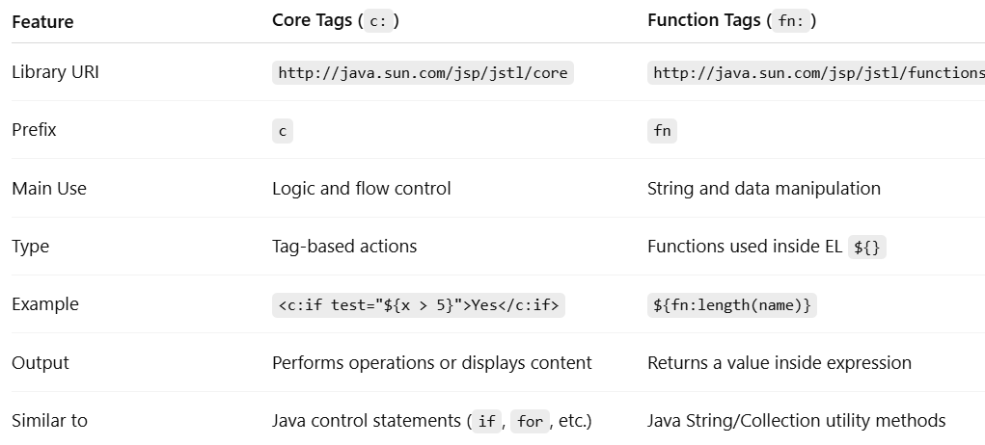

**Servlets:**

A **Servlet** is basically a **Java class** that handles **HTTP requests and responses**.

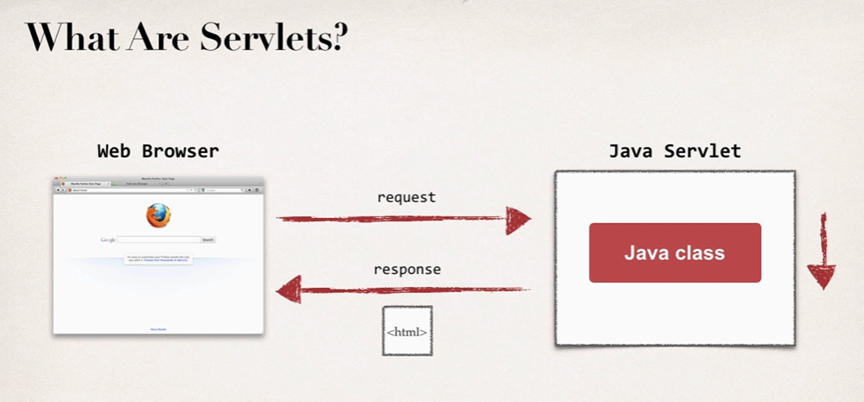

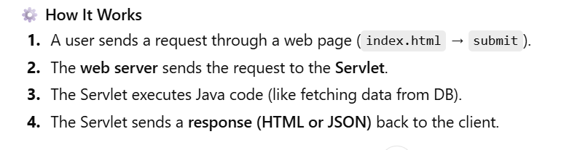

**Servlet vs Jsp:**

**Servlet: does the Business Logic**

**JSP: handles the Presentation view**

**MVC, Model View Controller – Design Pattern**

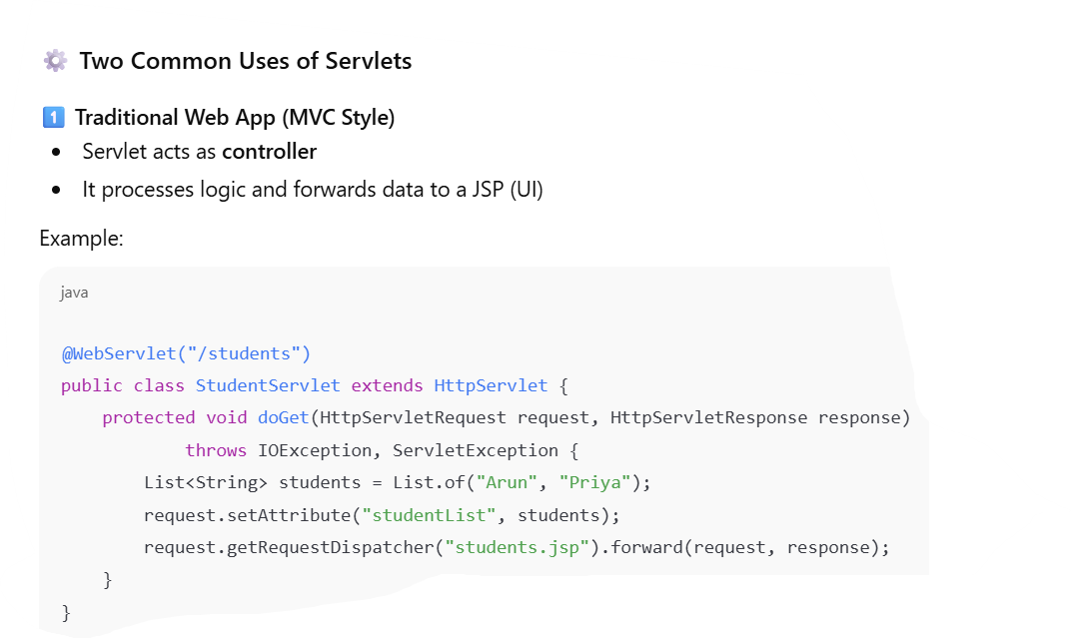

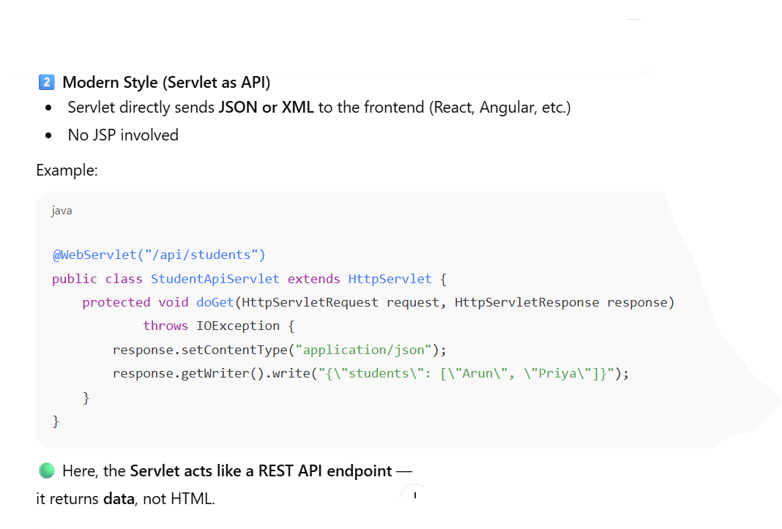

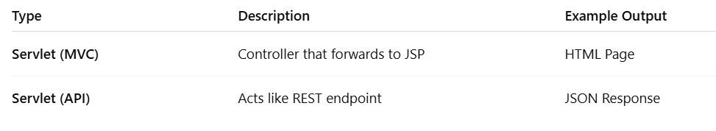

**Project:**

Create new dynamic project

Project Name: servletdemo

Source folder “src”(remove 🡪 src/java/main)

Content Directory: WebContent

Click Finish

**Create Package:**

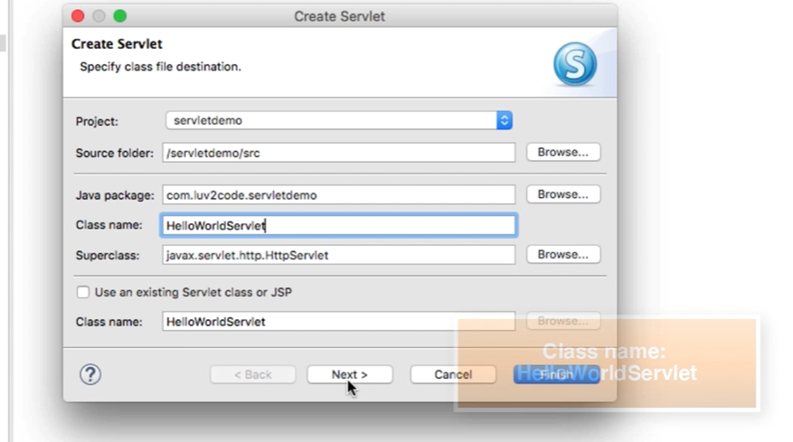

**Click Next 🡪 Click Next**

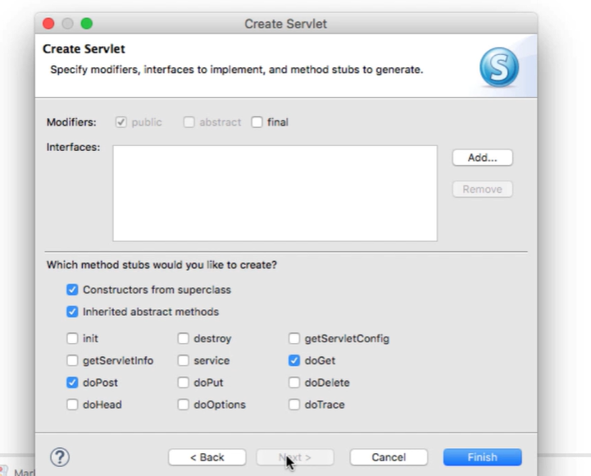

**Click Finish.**

**Go to src 🡪 package 🡪 java file**



Execute the program 🡪 Run on server.

**Reading HTML Form Data with Servlets:**

Img1 and 2

Program:

1. Create Html form
   1. WebContent -> new File 🡪 “student-form.html”

<html>

<body>

<form action="StudentServlet" method="GET">

First name: <input type="text" name="firstName" />

<br/><br/>

Last name: <input type="text" name="lastName" />

<br/><br/>

<input type="submit" value="Submit" />

</form>

</body>

</html>

1. Create Servlet
   1. Go to src 🡪 Create file “StudentServlet.java”
   2. Write code



* 1. Request : contains the form data from html
  2. getParameter: read Form data

1. student-form.html 🡪 Run on server

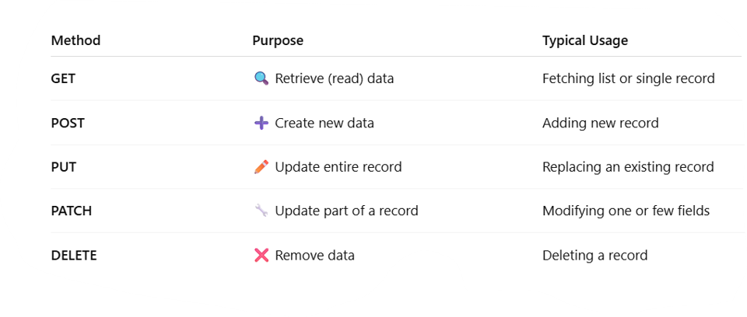

**Reading Servlets Parameters:**

Web app can make use of configuration parameters

It is located in WEB-IF/web.xml

Program:

1. Go to Webcontent 🡪 WEB-IF/web.xml

<?xml version="1.0" encoding="UTF-8"?>

<web-app xmlns:xsi="http://www.w3.org/2001/XMLSchema-instance" xmlns="http://xmlns.jcp.org/xml/ns/javaee" xsi:schemaLocation="http://xmlns.jcp.org/xml/ns/javaee http://xmlns.jcp.org/xml/ns/javaee/web-app_3_1.xsd" id="WebApp_ID" version="3.1">

<display-name>servletdemo</display-name>

<context-param>

<param-name>max-shopping-cart-size</param-name>

<param-value>99</param-value>

</context-param>

<context-param>

<param-name>project-team-name</param-name>

<param-value>The Coding Gurus</param-value>

</context-param>

<welcome-file-list>

<welcome-file>index.html</welcome-file>

<welcome-file>index.htm</welcome-file>

<welcome-file>index.jsp</welcome-file>

<welcome-file>default.html</welcome-file>

<welcome-file>default.htm</welcome-file>

<welcome-file>default.jsp</welcome-file>

</welcome-file-list>

</web-app>

1. Create Servlet
   1. Go to src 🡪 Create file “TestParamServlet.java”
   2. Write code



* 1. getServletContext() 🡪 class to read/parse web.xml

1. TestParamServlet.java 🡪 Run on server